1.1 Baptism
This unit presents Mark’s account of ‘Jesus and the Children’ (Mark 10:13-16). Through this story children can experience Jesus as one who welcomes, loves and includes them. In this story children are valued. They are people who enjoy a relationship with Jesus and the kingdom.
The unit introduces Baptism as the sacrament of initiation into the Church community. The emphasis here is on sharing in the new life of Christ. The unit presents the key symbols and actions used in the Rite of Baptism.

Outcomes
Students will be able to:
S1.3 demonstrate basic knowledge and understanding of Jesus and his teachings
S1.7.2 identify key symbols, signs and rituals of the Catholic Tradition
S1.7.3 demonstrate basic understanding of the Sacrament of Baptism

Scripture | Doctrine
Students are introduced to doctrine through Scripture and the living Tradition of the Church.
Mark 10:13–16 Jesus and the Children | - The Spirit of Jesus lives within us
Isaiah 43:1 I have called you by your name, you are mine | - We are baptised in the name of the Father, the Son and the Holy Spirit
- At Baptism I am welcomed into the Church
- Water, oil and light are key symbols of Baptism
 | - In Baptism we receive God’s Holy Spirit

Spiritual Reflection for Teachers
When James was working for a charitable organisation he met many refugee families who had come from overseas and were settling into Australia. Whilst there was not always a great deal of money, these families were very keen to invite others to their homes.
James remembers one Sudanese family in particular. They invited him for dinner and when he arrived he was overcome by their welcome - wonderful smiles and warm embraces from the children. The family had very little money yet they had gone to great efforts with the preparation of the meal.
James knew that this meal would have included most of their food for the week. When he left that evening he was filled with a great warmth and a sense of love. He would never forget this meal with the family. He decided to practise this form of welcome and hospitality in his own life.
“Practise hospitality, and therefore, imitating Christ's example and sharing in his love, welcome the brother or sister in need.” (John Paul II, in ‘Familiaris Consortio’)
- Has there been a time in your life when someone has made you feel very welcome? What happened or what did they do?
- Recall a time when you have welcomed another.
- All cultures have their own ways of welcoming people, eg a meal, a hug. What are some ways that are most meaningful to you?

Catechism of the Catholic Church
Excerpts from the Catechism of the Catholic Church are included below as information for teachers. They present the Church’s teachings contained in the unit.
- Everyone is called to enter the kingdom. First announced to the children of Israel, this messianic kingdom is intended to accept people of all nations. To enter it, one must first accept Jesus’ word:
The word of the Lord is compared to a seed which is sown in a field; those who hear it with faith and are numbered among the little flock of Christ have truly received the kingdom. Then, by its own power, the seed sprouts and grows until the harvest. (Lumen Gentium 5)
1267 Baptism makes us members of the Body of Christ: ‘Therefore … we are members of one another.’ Baptism incorporates us into the Church. From the baptismal fonts is born the one People of God of the New Covenant, which transcends all the natural or human limits of nations, cultures, races, and sexes: “For by one Spirit we have all been baptised into one body.”
1278 The essential rite of Baptism consists in immersing the candidate in water or pouring water on his head, while pronouncing the invocation of the Most Holy Trinity: the Father, the Son, and the Holy Spirit.
1282 Since the earliest times, Baptism has been administered to children, for it is a grace and a gift of God that does not presuppose any human merit; children are baptised in the faith of the Church. Entry into Christian life gives access to true freedom.

Scripture: Background Information
Mark 10:13–16 Jesus and the Children
Those who recognise and receive God’s kingdom as a gift, just as a child receives a gift, can expect to be part of the kingdom. The reference to Jesus’ indignation towards the disciples reflects his disappointment at their failure to understand the nature of the kingdom of God. It is beyond human power and status. It belongs to the little ones, the poor – those who acknowledge their need of God.
“In this passage, children are taken seriously as persons and enjoy a relationship with Jesus and the Kingdom.”

Isaiah 43:1 I have called you by your name, you are mine
This text is from the second part of the Book of Isaiah. It was written during or towards the end of the Exile in the sixth century BC, and for a people feeling despondent. Life was indeed difficult for them. They had lost their home, their Temple and their capital city. All had been destroyed in battle and they had been taken as prisoners to a foreign country. Still they are encouraged not to give up hope. “Do not be afraid for I have redeemed you; I have called you by your name, you are mine.”(v1).
The Hebrew words give some marvelous insights into just how close God is. In verse 1 it says “I have called you by your name, you are mine”. The words “you are mine”, literally translated from the Hebrew mean “to me you are” giving the sense that we exist in God – “to me you are”. Further, the words “I will be with you” literally translated from the Hebrew mean “with you I am” giving the sense that God exists in us.

Suggested Assessment
Suggestions for determining students’ development towards the achievement of the outcomes are included below:
S1.7.2 identify key symbols, signs and rituals of the Catholic Tradition
The student typically might:
- recognise and talk about key symbols, signs and rituals of Baptism
S1.7.3 demonstrate basic understanding of the Sacrament of Baptism
The student typically might:
- talk about the Sacrament of Baptism as a celebration of welcome into the Church community
- respond through oral or written expression, art, movement or wondering
- engage with the story through 3D materials

S1.3 demonstrate basic knowledge and understanding of Jesus and his teachings
The student typically might:
- retell the story of ‘Jesus and the Children’ identifying Jesus as the friend of children, welcoming them or telling the adults an important message
- indicate that Baptism and ‘belonging to the Church’ are connected

Resources
To Know Worship and Love – Book 1, Chapters 10 and 11, (2005), James Goold House Publications, Melbourne, Victoria
To Know Worship and Love – Posters, Baptism

Teacher Resources
Macdonald Anthony Sr, (2004), To God On A Magic Carpet, Spectrum Publications, PO Box 75, Richmond Vic, Australia
Wintour R, (2002), Just Imagine 2 – More Creative Ways Of Presenting Scripture, Mountjoy Enterprises, PO Box 5312 Manly, Brisbane, Australia

Audio Visual
Compilations, (1982), As One Voice, Volumes 1 & 2, Willow Connection, Sydney
Compilations, (2002), As One Voice For Kids, Willow Connection Pty Ltd and Open Book Publishing, Australia
Kearney P, (2003), Together As One from Growing in God, Crossover Music, PO Box 496 Mittagong NSW
Landry C & Kinghorn C J, (1973), ‘Come Along With Me To Jesus’, Hi God 2
Maranatha Music, ‘Welcome to the Family’, Kids Praise! 3, Maranatha Music, California, USA
Walker C, (1991), ‘We Are The Church’, As One Voice, Vol 2, Willow Connection, Sydney
Walker C, (1992), ‘Like A Child Rests’, As One Voice, Willow Connection, Sydney
Willcock C, (1980), ‘Do Not Be Afraid’, As One Voice, Vol. 2, Willow Connection, Sydney

NOTE: See RE Online for additional resources for this unit.

Unit Content A: Belonging

Jesus loves and welcomes little children.
Students will:
- listen and respond to the story of Jesus and the children
- reflect on the qualities of Jesus, identified in the story

Background Information
It is recommended that this ‘Unit Content A’ be completed at the beginning of the school year to set an atmosphere of welcoming and belonging in the new Year 1 classroom. The content explores the human experiences of welcoming, belonging, relating, meeting and celebrating together. Through the Unit Content teachers have the opportunity to engage the children in feeling comfortable and affirmed in their transition from Kindergarten to Year 1.
The Scripture story for this unit has themes of being welcomed and loved by Jesus. It is important that students are given opportunity to engage with and reflect on this Scripture story of Jesus and the Children so they can develop their understanding of Jesus as a friend who welcomes and affirms them in a special way. This unit is laying foundations, through the story, for students to develop a relationship of love and trust with Jesus.
The Scripture story highlights the importance of being like little children to enter God’s kingdom. This is reflected in the Catechism: “The kingdom belongs to the poor and lowly, which means those who have accepted it with humble hearts. Jesus is sent to “preach good news to the poor., He declares them blessed, for “theirs is the kingdom of heaven”. To them – the “little ones”, the Father is pleased to reveal what remains hidden from the wise and the learned.”
Children may well be thought of as being among the ‘lowly’ and the powerless of this world. However, in their candour and simplicity these ‘little ones’ are able to teach adults much. Teachers have this opportunity, especially when exploring the ‘I wonder’ statements with them. Jesus, the Good Shepherd, welcomes his children and they respond to his love. To such as these belongs the Kingdom of God.

Suggested teaching/learning strategies
The following suggested activities are organised around the key elements of Telling the Story, Wondering, Exploring and Prayer. Teachers select, adapt or substitute activities, ensuring that each of the abovementioned elements is evident in the cycle of learning.
- Welcoming Activity
  - Teacher creates an invitation (see ‘Resource Sheet 1’) to give to the class inviting the children to come to the class prayer place. Through the invitation, the teacher emphasises that they will be welcomed in a special way to their Year 1 classroom.
  - As the children gather in the prayer place, the teacher warmly greets and welcomes each child by name, saying, “Welcome………, peace be with you” with a welcoming gesture, eg handshake, smile. Children are invited to welcome each other in a similar way. Pose question: Do you know of other times when we welcome and greet others in this way?
  - Teacher invites the children to share ideas about how people are welcomed in our homes, in our classroom and in our school. How were they initially welcomed to school? Talk about how we feel when we are welcomed. What does welcome feel like? Are there times when we feel unwelcome? How does that feel? Role play examples of welcome/ unwelcome using gestures, facial expressions, body movements. This is an opportunity for the teacher to ‘welcome’ all ideas and sharing.
  - Sing a welcome/gathering song, eg ‘Welcome to the Family’, or ‘Together As One’
  - Welcoming activity could end with the sharing of special party food in a celebratory atmosphere.
- Gather children in a circle or in the story telling place. Welcome each child in a similar way to the previous welcoming activity. Tell the children that in the Bible there is a story about a time when Jesus welcomed little children. Using the script from ‘Resource Sheet 2’ and 3D figures, tell the story of ‘Jesus and the Children’.
- Use some of the ‘I wonders’ on KWL p78 to engage the children in wondering about the story.
- In rotational groups, children engage in the following:
  - Retell the Scripture story using the 3D figures.
  - Children reflect on how Jesus loves and cares for them. Use sentence stem: Jesus is my special friend and he cares for me by… Children write down their ideas. Share with a partner.
  - Children devise simple movements to accompany the song ‘Come Along With Me To Jesus’ by Carey Landry from Hi God 2.
- Sing a hymn related to the theme of Jesus being a friend. As One Voice For Kids and As One Voice 1 & 2 have a range of hymns about Jesus being our friend and Jesus loving and caring for us.
- Discuss greeting words: hello, g’day, welcome, how do you do, hi, nice to meet you. Share any greetings from other nationalities from within the class, eg French - bonjour, Chinese – nei hou, Tongan – malo e lelei, Italian – ciao, Hebrew – shalom, Dutch – hallo, Danish – hej, Spanish – hola, Irish – fáilte, Japanese – kinnichiwa, Indonesian – selamat pagi.
- Children choose a greeting word and create a poster/sign to be placed at the entrance to the classroom. Children paint and decorate their sign of welcome. WordArt on the computer could be used for the greeting words.

- Revisit the story of ‘Jesus and the Children’ by reading through KWL ch10. Invite children to share ideas about the story referring to the pictures in KWL. Some points for discussion could centre around questions of: “How do you know that Jesus loved the children?” and “How did Jesus show that he cared?”
- Using percussion instruments, create a musical interpretation of the story – use the instruments to express the emotions in the story.
- Further exploration of the story can be done using Liquid Pictures and/or Echo Mime. Scripts and suggestions for both Liquid Pictures and Echo Mime for the Scripture of Jesus and the Children can be found in Rina Wintour’s Just Imagine 2 – More Creative Ways of Presenting Scripture pp50–51.
- Encourage children to talk about people at school, home, community who demonstrate these qualities.
- Meditation on what children might talk to Jesus about. There is an example in To God On A Magic Carpet, p11, ‘Meeting Jesus’. This visualisation takes the children on an experience of meeting and walking with Jesus. The children are invited to talk to Jesus and to imagine what Jesus might say to them in return.
- Children journal one thing that they would like to say to Jesus. Children may like to draw themselves with Jesus. Display children’s work.
- Use prayer from KWL p79, which uses the imagery of being held by God like a child asleep in its mother’s arms. Sing refrain from Christopher Walker’s song ‘Like a Child Rests’
- Send KWL book home with a note to parents to read the Home Activity suggestion. You might suggest in the note that implementing this suggestion will support the child’s Religious Education development in this particular area and encourage parents to talk about illustrations in the book.

Unit Content B: The Sacrament of Baptism
Through the Sacrament of Baptism we are initiated into the Church community.
Students will:
- explore Baptism as a way of becoming part of the Church family and sharing in the life of Christ
- learn about the key symbols and rituals of Baptism

Background Information
In this Unit Content students are introduced to the Sacrament of Baptism as the special time when we are first initiated into the Church community and united with all other baptised persons. In the words of the Catechism, “From the baptismal fonts is born the one People of God of the New Covenant, which transcends all the natural or human limits of nations, cultures, races and sexes: ‘For by one Spirit we were all baptised into one body’ (1 Cor 12:13).”
The Sacrament of Baptism is a community celebration and follows a pattern of actions, rituals and words. Sometimes Baptism is part of the celebration of the Eucharist in which the Church community celebrates the central mystery of Christ’s death and Resurrection. Other times Baptism is celebrated outside of the Eucharist. Most commonly the celebration of Baptism is held in the parish church to which the baptised person belongs. In the context of this unit, the suggested activities focus on infant Baptism, as it is the most recognisable focus for Year 1 children.
In the celebration of Baptism symbols are used. These symbols and actions and the words accompanying them help to understand what is happening. In the story script provided (Resource Sheet 3) we draw from the whole celebration of Baptism key actions and symbols only, to assist the children to learn through these symbols, actions and words. Although the person to be baptized is anointed initially with the oil of catechumens after the Prayer of Exorcism we do not include this in the script as the child may confuse it with the later anointing with the oil of Chrism.
In telling this ‘story’ of Baptism, we are not conducting a Baptism, nor are we simply talking about Baptism. We are incorporating key symbols, rituals and words in our story, so that children can experience these as ways of thinking and learning about this sacrament.
The key symbols of the sacrament introduced at this foundational stage are:
- Water – poured over the baptised person’s head three times or the person is immersed in water as the priest says, “…I baptise you in the name of the Father, and of the Son, and of the Holy Spirit.” Water in Baptism is a symbol of the new life God gives us, cleansed and made new in Christ Jesus.
- Oil of Chrism – perfumed oil used to anoint the person being baptised. In ancient times kings, queens, priests and sometimes prophets were anointed with oil to strengthen them for their mission. At Baptism this anointing signifies that the newly baptised person shares in the mission of Jesus Christ as priest, prophet and king. It signifies that the person has received the gift of the Holy Spirit to strengthen them for this mission.
Key signs from the Baptismal liturgy which tell of the effects of the sacrament are the:
- White Garment – a sign that the baptised person has “put on Christ” (Gal 3:27). It is an outward sign of the newly-baptised’s Christian dignity.
- Lighted Candle – lit from the Easter (Paschal) candle which represents Christ, the Light of the World. The parents or godparents usually light this candle. They are asked to help the child walk always as a child of the light and to keep the flame of faith alive in his or her heart.

Suggested teaching/learning strategies
The following suggested activities are organised around the key elements of Telling the Story, Wondering, Exploring and Prayer. Teachers select, adapt or substitute activities, ensuring that each of the abovementioned elements is evident in the cycle of learning.
  - Make connections to previous ‘Unit Content A: Belonging’ and discuss with the children that Jesus especially welcomes little children. Tell the children that the Church has special times when we celebrate our friendship with Jesus – we call these Sacraments. Write or display the word Sacrament and explain to the children that one of these special times is the Sacrament of Baptism. Write or display the word Baptism and say: “Baptism is a special meeting with Jesus”.
  - Tell the liturgical story of Baptism using ‘Resource Sheet 3’ and the suggested concrete materials.
  - Use some of the ‘I wonder’ statements in KWL p86 to engage children in dialogue about this story and/or Baptism.
  - Place the concrete symbols/materials used to tell the liturgical story of Baptism near class prayer space and allow the children opportunities to engage with the symbols. Invite the children to retell the story of Baptism in their own words using the materials.
  - Identify special celebrations, e.g. birthdays, weddings, anniversaries. Students describe some of the actions and symbols of different celebrations. Complete a class strategy - What you already know, what you want to find out and what you have learned about Baptism. Display pictures of a Baptism using KWL Baptism poster set. Encourage the children to look carefully at the story being told through the pictures. Focus on Baptism as a celebration and as a special time when people become members of the Church.
  - Children draw symbols of Baptism using the story materials as a guide. Children write captions to identify what is happening. Display the children’s work.
  - Discuss with the children the word ‘symbol’. Use ‘Resource Sheet 4’ to match the symbols of Baptism with the actions. Display.
  - Invite the children to interview their parents about their own Baptism, find out who baptised them, the date and who their godparents are. Children not baptised could interview their parents about what celebrations happened when they were born. Ask the children to bring in items from home of their Baptism, eg photos, baptismal candle, baptismal certificate. Allow the children to share their Baptismal stories with each other. These could be incorporated into ‘news time’ or completed as a ‘Topic Talk’ – when, where, who, what and why.
  - Children write sentences for display: My name is … I was baptised at… My godparents are…
  - Children display photos of their Baptism with the caption, I belong to the Parish family of…

  - Design a “Who’s who” of people involved in the celebration of the Sacrament of Baptism eg priest, child, parents, godparents, family members, Church family.
  - Sing a hymn related to the theme of Baptism. As One Voice For Kids and As One Voice 1 & 2 have a range of hymns about being welcomed into the Church family and Baptism.
  - If possible, visit the church and identify the baptismal font. Invite the parish priest to come and talk to the class about the Sacrament of Baptism. Invite the priest to talk about his role in the Sacrament of Baptism and what the main symbols and actions are.
  - Tell the children that an important part of the Sacrament is when the priest baptises the child by using the child’s own name. It is good for children at this age to focus on the particular names given to them at Baptism. Everyone’s name is sacred as it represents the person who bears it. God knows each of us by name. Allow the children time to reflect on their names and on their special dignity as part of the Body of Christ.
  - Sing hymn, ‘Do Not Be Afraid’ by Christopher Willcock which has the refrain, ‘Do not be afraid I am with you, I have called you by your name, you are mine. I have called you by your name, you are mine.’ Devise movements to accompany the singing of the hymn.
  - Read the words from Isaiah 43:1, ‘I have called you by name, you are mine.’ Use in class prayer time. With children seated in a circle invite each child to come forward and receive a card or a badge with the words ‘I have called you by name, you are mine’. Children can write their own name on the card/badge and decorate. When giving out the cards, teacher individually names each child saying, “God has called you… [name of child] and you belong to God”. During the prayer, focus on the Sign of the Cross and remind the children that they are baptised in the name of the Father, and of the Son, and of the Holy Spirit.
  - Celebrate with the children a Liturgy of the Word which includes a simple renewal of Baptismal promises. Invite parents to join the celebration.

Resource Sheet 1
A Special Invitation of WELCOME

Dear________________,
You are invited to join your class at a special meeting place.
Where: Our Classroom Prayer Place
When ______________

From ______________
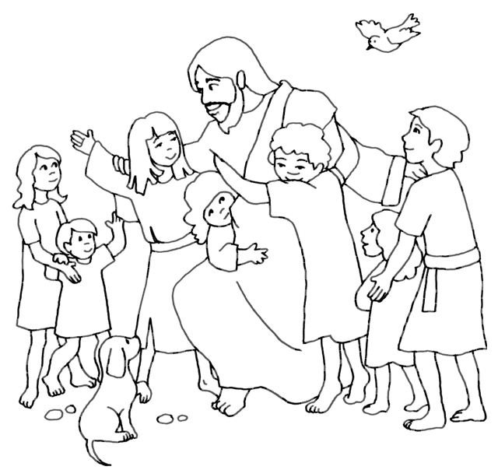

A Special Invitation of WELCOME

Dear________________,
You are invited to join your class at a special meeting place.
Where: Our Classroom Prayer Place
When ______________

From ______________

Resource Sheet 2
Jesus and the children
Adapted from KWL Chapter 10
(Mark 10:13–16)
YOU WILL NEED:
- 3D figures for Jesus, 2 apostles, 4 children
- green cloth for grass

Children are seated in a semi-circle ready to listen to the story. Carry the materials carefully to the circle and place them beside you. Roll out the green cloth as you say…
We all like to feel that we are welcome and that we belong. It is a good feeling to have. In the Bible there is a story about a time when Jesus welcomed and blessed little children.
Present Jesus figure, place him in the story space and say …
This is Jesus. He is talking with some friends.
Move disciples to either side of Jesus.
They are called his disciples. One day, some people brought their children to Jesus.
Put people and children figures on cloth and move towards Jesus.
They wanted Jesus to meet their children and give them a blessing.
Move the children towards Jesus.
Jesus’ disciples started to send them away, saying that he was too busy with the adults.
Move the disciples to block the children from Jesus.
But Jesus saw what was happening and he was very upset with his disciples for wanting to send the children away.
Move Jesus and place him between the disciples and children say …
“Let the children come to me,” he said, “and don’t stop them! Because God’s kingdom belongs to people who are just like them.”
Place children in a semi circle around Jesus and say …
Jesus told all the adults that they had to be more like little children – learning to trust God just like a child has to trust its mother or father. Then they would shine with God’s love.
Hold your right hand over each child’s head in the sign of blessing whilst you say…
Jesus then welcomed all the children into his arms and hugged them. He placed his hands on their heads and gave them his blessing.
The children knew that Jesus loved them because God’s love was shining in them.
Carefully pack story materials into storage box and put on shelf. Ensure that children are watching so they know how to pack the materials away and where to find them.
Resource Sheet 3
Baptism
Adapted from KWL Chapter 11
You will need:

- white felt or cloth
- a doll and basket
- a white blanket or garment
- large bowl of water for the baptismal font
- small pitcher of water
- perfumed oil
- large candle for the Paschal candle
- small candle and holder or container (not plastic) with sand to hold lighted candle
- matches
- small hand towel

Children are seated in a semi-circle ready to listen to the story. When the children are settled, go to the shelf and carry the materials as you would the Bible. Place these beside you.
Begin by spreading out the white cloth in front of you. Smooth it out and say:
Jesus told his friends to baptise people in the name of the Father and of the Son and of the Holy Spirit.
Pick up the bowl of water and pitcher. Place on white cloth and say:
In Baptism we use water – water cleans and renews, water keeps us alive. Jesus was baptised in water.
Pick up the large candle and place on white cloth.
Light the candle as you say:
This is the Easter candle. Jesus said “I am the Light of the World”.
Put small container of oil on white cloth saying:
This is perfumed oil – that heals and strengthens, oil that kings, queens, priests and prophets were anointed with to strengthen them for their special work.
Pick up baby doll and say:
Today I’ll use this baby doll to show what happens in Baptism. It’s not always babies that are baptised. Sometimes people are older when they are baptised.
The priest meets everyone at the entrance to the church. He asks the parents “What name do you give your child?” We’d better give this baby a name. Look up and say, What name will we give this child? Take the first name suggested, and say clearly and distinctly:
(N………………), the Christian community welcomes you with great joy. In its name, I claim you for Christ, our Saviour. The priest makes the sign of the cross on the baby’s forehead and invites the parents and godparents to do the same.
Make the Sign of the Cross on the doll’s head and invite two or three children to do this also.
Gently place the baby back in the basket and continue.
The people listen to the Word of God (point to the Bible in the prayer place), say some prayers and gather around the font of water.

Move large bowl of water in front of you and pick up the doll again. Fill small pitcher of water from the large bowl (baptismal font). Pour water three times over the doll’s head as you say clearly and distinctly:
(N………………), I baptise you in the name of the Father and of the Son and of the Holy Spirit.
Put some oil on your finger, make a cross on the doll’s head and say:
God our Father anoints you with the oil of Chrism. May you live always as a member of his body.
Wipe the doll’s forehead with towel and pick up white garment. Put it over the doll as you say:
(N………………), you are clothed in Christ. See in this white garment the sign of your Christian dignity.
Put doll back in basket. Pick up Easter candle, hold near doll and say:
The baby is given a candle that is lit from the Easter candle (Paschal candle). The priest asks the parents and godparents to help the child “to live always as a child of the light”.
Finally pick the doll up, cradling it and say:
When babies are born, they become part of a family.
When a person is baptised, that person becomes part of the Church.
Put doll back in basket and pause for a moment or two before engaging children with some of the ‘I wonders’.
Carefully pack story materials into storage box and put on shelf. Ensure that children are watching so they know how to pack the materials away and where to find them.

Resource Sheet 4

Cut out the symbols of Baptism and glue below the matching caption
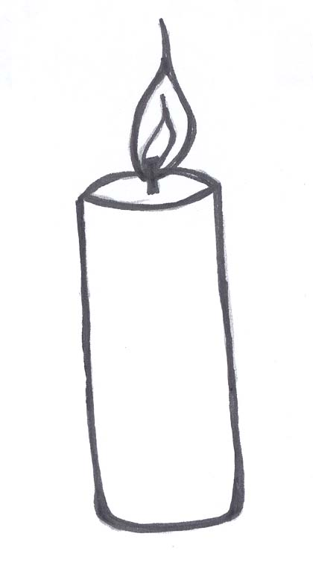 | 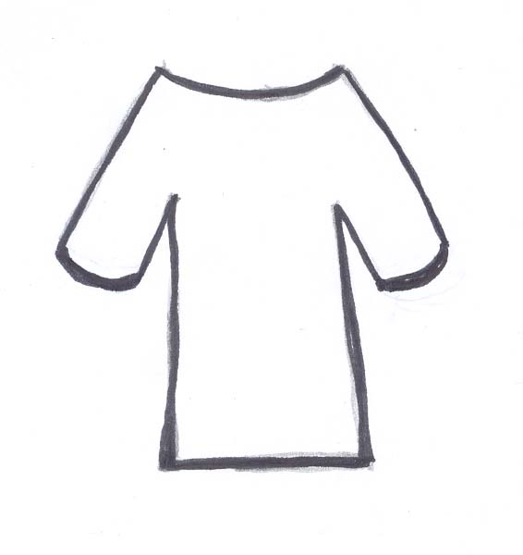 | 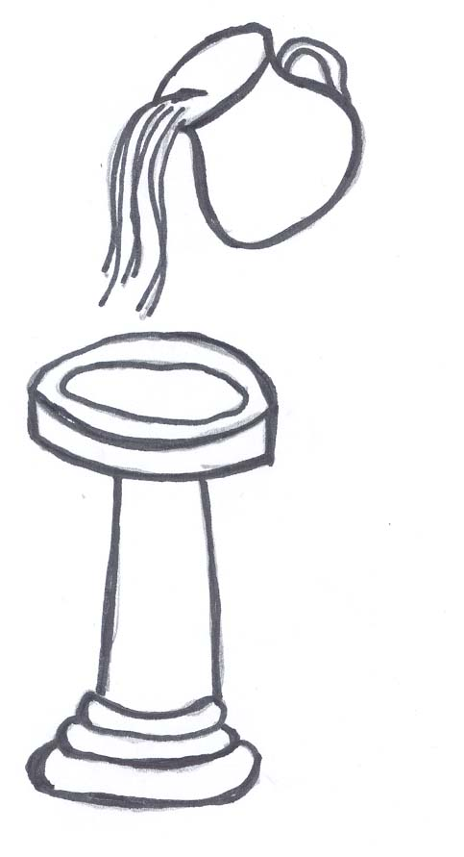

Baptism welcomes people into the Church community
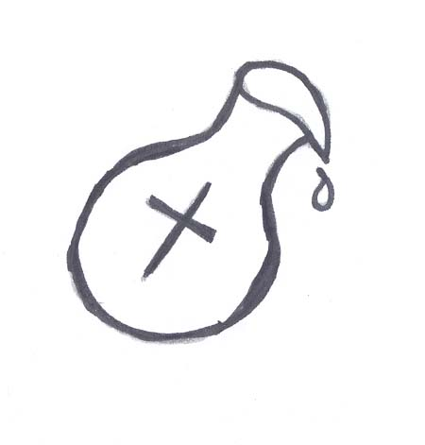

We are baptised with water in the name of the Father, and of the Son, and of the Holy Spirit | We are anointed with the oil of Chrism | A candle is lit from the Easter candle | We are given a white garment to wear

Brown R E, Fitzmyer S J, Murphy R E (eds), (1990), The New Jerome Biblical Commentary, Prentice Hall Inc, New Jersey
Catechism of the Catholic Church, n544
Adapted from To Know, Worship and Love Teaching Companion Level 2, (2001), James Goold House Publications, Melbourne, p118
Catechism of the Catholic Church, n1267

